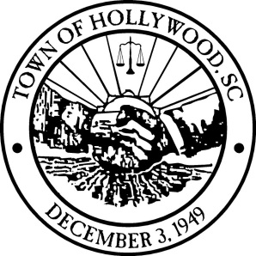
Mayor Jacquelyn S. Heyward

Public Input Needed – Where and How Should Growth Occur in the Town of Hollywood
A Public workshop will be held to gather public input for the Town of Hollywood’s Comprehensive Plan Five-Year Update.

The Town of Hollywood completed the five-year update of the Town of Hollywood Comprehensive Plan and is now in the process of implementing the findings of their review. The purpose of this five-year review and update of the Comprehensive Plan is to:
- Review/revise the future land use designations to reflect current demographic trends an community needs and desires;
- Update the existing conditions of all Plan elements, including updating demographic and statistical data;
- Review/revise the goals, needs, and strategies of all Plan elements;

A public workshop will be held to gather public input on the proposed amendments. The workshop will be set up as a drop-in format, where attendees can view the proposed amendments at their own pace and submit comments and suggestions before leaving the workshops.
The five public workshop locations include:

Tuesday, September 22, 2015 (6 PM - 8 PM)
Hollywood Town Hall
6278 Highway 162
Hollywood, SC 29449

What is the Comprehensive Plan?
- The Comprehensive Plan is an expression of the Town’s intent for where and how future growth and development should occur. The plan also identifies parts of the County that may or may not be appropriate for certain types of growth, given the Town’s unique character and natural conditions.

Why does the Comprehensive Plan need to be reviewed?
- Title 6, Chapter 29 of the South Carolina Code of Laws requires that the Comprehensive Plan be reviewed at least once every five years and updated at least once every ten years.

Who is involved in the update process?
- The public;
- Stakeholders;
- Hollywood Town Council;
- Hollywood Planning Commission; and
- Town of Hollywood Planning and Zoning Department staff.

